# MINI PROJECT (2020-21)

**WEB Tech : Education Hub**

**MID-TERM REPORT**



**Institute of Engineering & Technology**

**Submitted by:**

Aakhya Swamiwal (181500001)

Kishori Agrawal (181500326)

Divya Baghel (181500218)

Ayushi Agrawal(181500182)

***Supervised By: -***

**Mr. Manoj Varshney**

**Technical Trainer**

# Department of Computer Engineering & Applications

**Contents**

|  |  |
| --- | --- |
| **Abstract** | **3** |
| **1. Introduction** | **4** |
| 1.1 General Introduction to the topic | **4** |
| 1.2 Why Web Tech:Education Hub | **5** |
| 1.3 Hardware and Software Requirements | **6** |
| **2. Problem definition** | **7** |
| **3. Objectives** | **8** |
| 4**. Implementation Details** | **11** |
| **5. Progress till Date & The Remaining work** | **11** |
| **6. Some Screenshots** | **12** |
| **7. References** | **13** |

**Abstract**

One primary aim of this project is to develop a next generation online educational platform –"Web Tech". The platform should allow students to log in,sign up the system, collect their learning materials, and discuss with their classmates,teachers, doing online test… . The major advantage is that, the entire things process is real-time and online, which means the student can study everywhere (e.g. at home).

The objectives of the development of this web-based learning system are to encourage the freedom of self-learning, to promote interaction and cooperation between teachers and students related to different concepts. Because online learning provides flexibility of time,its work is fast,there is no need of any paper work,more security of data is there.

Student-centered learning is one of several many learning management systems that encourage students to learn and solve problems independently . It also encourages students to use information technology to benefit their learning process. Thus, web-based learning, is another form of technology that can support independent learning. Furthermore, these technologies are also adopted side by side with classroom management. In order to efficiently manage web-based learning, teachers need to consider the process and method that is consistent and suitable for teaching specific subjects.

# 

# Introduction

* 1. **General Introduction to the topic**

Web-based e-learning environments added new dimensions in designing course contents. Learning systems properly utilize such capabilities for more effective learning outcomes. In other words, e-learning is the best teaching methods to use for a specific student or group of students knowing that every one has his/her own learning objectives, motivations, knowledge, and skills. The main objective of this project is to make a website in which user can login , signup ,chat with teachers using **CHAT APP** ,can give feedbacks and many other things which are needed in e-learning website. The idea is to embed education methods and learning and cognitive theories into e-learning environments to provide a more intelligent and, hence, more adaptive and effective one-to-one e-learning environments.

Many students faces problem like hesitation, not cleared of concepts, lack of money. Henceforth, we are working on project that is mainly for students facing such problems in their curriculum but don’t have solution of it. With this project it helps not only students but also who are not going to school but wants to gain knowledge. It can be easily accessible content related to academics as well as extra information regarding many topics that would help them in enhance their knowledge.

# About Chat App: -

# Messaging apps ( "social messaging" or "chat applications") are apps and platforms that enable instant messaging. Many such apps have developed into broad platforms enabling status updates, chatbots, payments and conversational commerce (e-commerce via chat). They are normally centralised networks run by the servers of the platform's operators, unlike peer-to-peer protocols like XMPP

# Some examples of popular messaging apps include WhatsApp, Facebook Messenger,Telegram, Viber, Line, and Snapchat. The popularity of certain apps greatly differ between different countries. Certain apps have emphasis on certain uses - for example Skype focuses on video calling, Slack focuses on messaging and file sharing for work teams, and Snapchat focuses on image messages. Some social networking services offer messaging services as a component of their overall platform, such as Facebook's

# Facebook Messenger, while others have a direct messaging function as an additional adjunct component of their social networking platforms, like Instagram, Reddit, and Twitter, either directly or through chat rooms.

# How Chat App Works: -

# A chat application has the following components: a messaging application, a server and a persistent connection. ... It is only because of this connection that you are able to send messages to others who are connected to the same server and others are able to see you online and send messages to you.

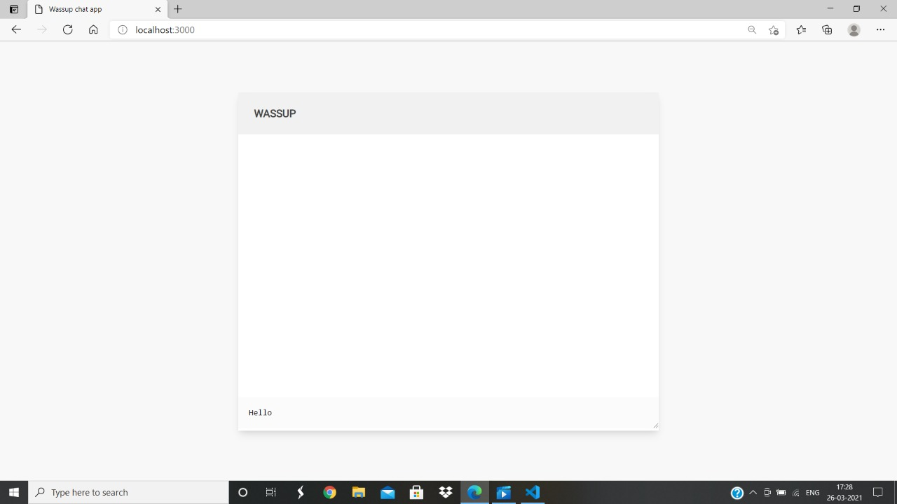

# Why Web Tech:Education Hub?

# E-Learning has completely transformed the way in which learning is imparted to students. Unlike traditional chalk and board method of teaching, eLearning makes learning simpler, easier, and more effective.

### Online Learning Accommodates Everyone’s Needs

The online method of learning is best suited for everyone. This digital revolution has led to remarkable changes in how the content is accessed, consumed, discussed, and shared. Online educational courses can be taken up by office goers and housewives too, at the time that suits them. Depending on their availability and comfort, many people choose to learn at weekends or evenings.

### 1. Lectures Can Be Taken Any Number Of Times

Unlike classroom teaching, with online learning you can access the content an unlimited number of times. This is especially required at the time of revision when preparing for an exam. In traditional form of learning, if you can not attend the lecture, then you have to prepare for that topic on your own; in eLearning, you can attend the lectures whenever you want with ease.

### 2. Scalability

E-Learning helps in creating and communicating new training, policies, concepts, and ideas. Whether it is for formal education or entertainment, eLearning is very quick way of learning!

### 3. Consistency

E-Learning enables educators to get a higher degree of coverage to communicate the message in a consistent way for their target audience. This ensures that all learners receive the same type of training with this learning mode.

### 4. Reduced Costs

E-Learning is cost effective as compared to traditional forms of learning.  The reason for this price reduction is because learning through this mode happens quickly and easily. A lot of training time is reduced with respect to trainers, travel, course materials, and accommodation.

# 1.3 HardwareRequirements

Processor : intel i3(or higher)

Operating System : Windows 10

RAM : 4GB(or higher)

Hardware Devices : Computer System

Hard disk : 256 GB

# Softwarerequirements

Technology Implemented : Front-end, Back-end Technology

Tools Used : Html, CSS, Javascript , Bootstrap,

React JS, Nodejs

Database : mongodb

User Interface Design : Visual Studio(Version 1.48)

# Objective

Enhance the quality of learning and teaching. Meet the learning style or needs of students. Improve the efficiency and effectiveness. Improve user-accessibility and time flexibility to engage learners in the learning process.With this project student not only enhance its knowledge from basic to advance even he/she can clear their doubts through chat application with our experts. Student can also test their knowledge with quizzes that helps them to make their concept stronger and clearer.

# Implementation Details

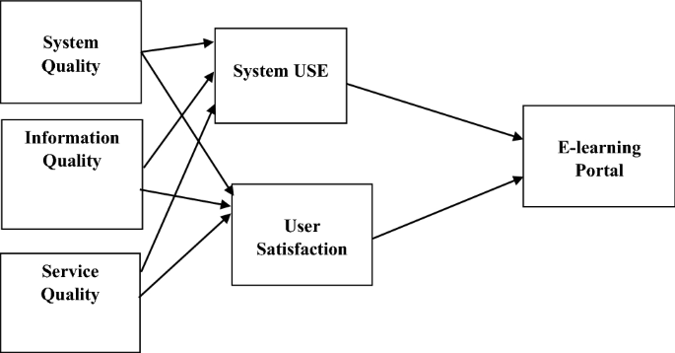

**Part1: Website Databases and Models**

Databases and Models A key defining aspect of any database-dependent application is its database structure. The database design can vary depending on many different factors, such as the number of reads over writes or the values that the user is likely to request the most. That is because as full stack developers we want the database to have the best performance, which can often be achieved by focusing the optimizations on the most common actions. We concentrated on the MongoDB database, which is the most complex data storage and the one which stores the most data. Our Redis data structure limits to mapping sessions to user identifiers, both of type text. That is how a web request works: Node.js queries Redis by using the user session identifier to determine whether the user is signed and their account identifier. If an account identifier is found, Node.js queries MongoDB to find out the rest of the user information. The MongoDB database stores everything else: users’ information, rooms, chats, and messages.32 Implementation of a chat application for developers Our final database design ended up having four different collections: users, rooms, chats, and messages. Although MongoDB is schema-less, by using the Mongoose library on Node.js, we were also able to define a flexible schema for each of the collections. A schema constrains the contents of a collection to a known format, saving us from validating the structure of the data before or after it has

Been putting into the database

**Part 2: Chat App part**

Chats As we stated earlier, our chats were going to be in individual collections. There might be chatboxr in which their members have few chats, but others might have hundreds (even if that leads to having a few inactive ones). Once again, we had to think whether it was worth embedding or referring messages inside the Chats collection or keeping them isolated in another one.

**Part 3: Authentication**

Authentication was our first feature to implement. We wanted to give support to local, GitHub and Google authentications. Server On the server-side, this implied creating a few new routes to handle sign in, sign up (only for local authentication) and sign out, and the appropriate strategies to handle each of these providers. For the local authentication we configured the following two routes: /auth/signup /auth/signin They handle the

register and the login form data respectively. For the authentications, we have these other ones: /auth/github /auth/github/callback /auth/google /auth/google/callback We have to have two endpoints for each OAuth authentication. The first one is the request one, which will bring the user to the provider’s authentication page, and the callback one is the return URL which the provider will bring the user to after having completed the authentication along with authentication tokens. It is to note that since we are handling all authentication server-side, even the callbacks, we do not return JSON in any of the Aouth routes. As an exception, we make use of redirects to client pages both when the authentication succeeded and when it errored (either because of a problem on our side or because the user declined to grant us

permission on the provider’s page)

# SCREENSHOTS

# C:\Users\Dell\Pictures\Screenshots\Screenshot (1127).png

Sign up page

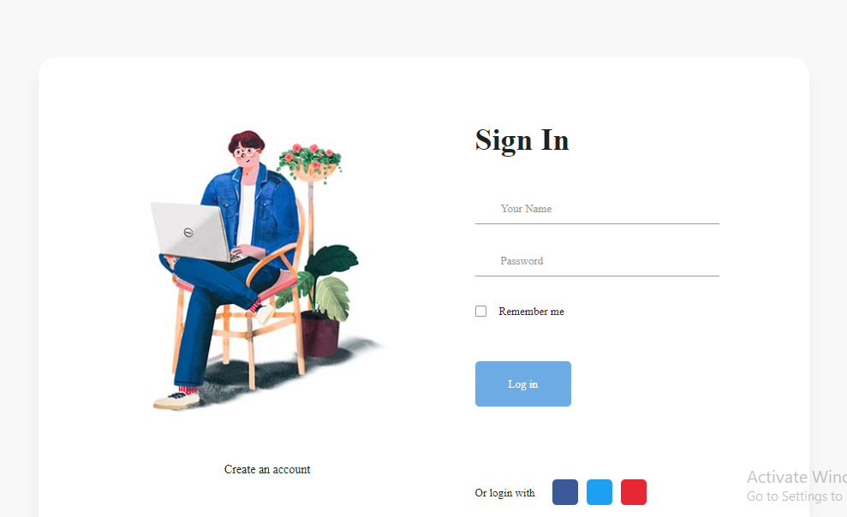

Sign In Page

Sign In Page

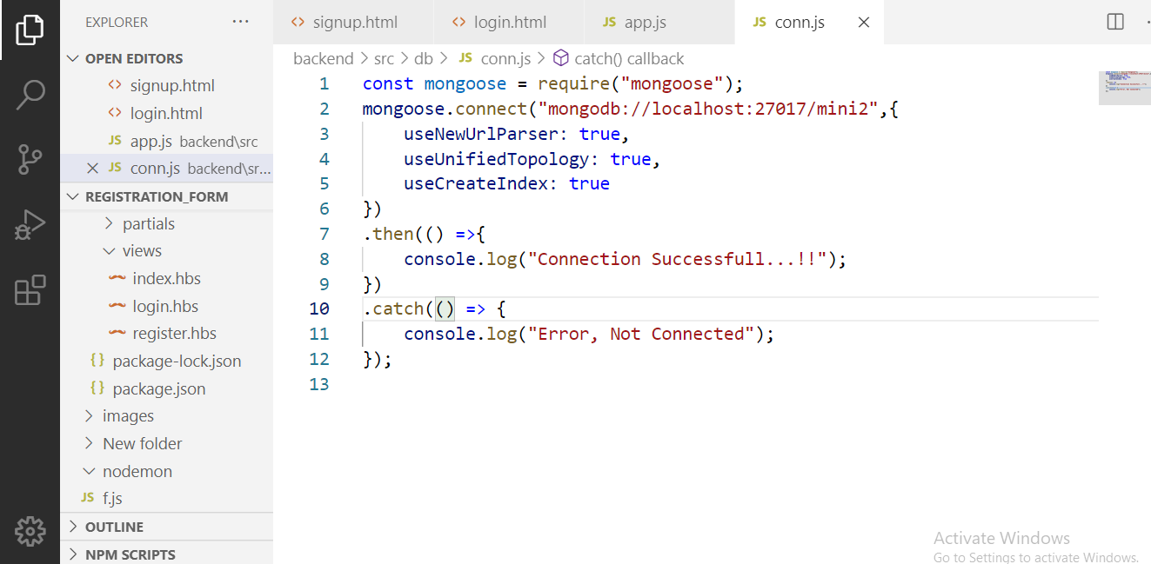

Data Base Connection file

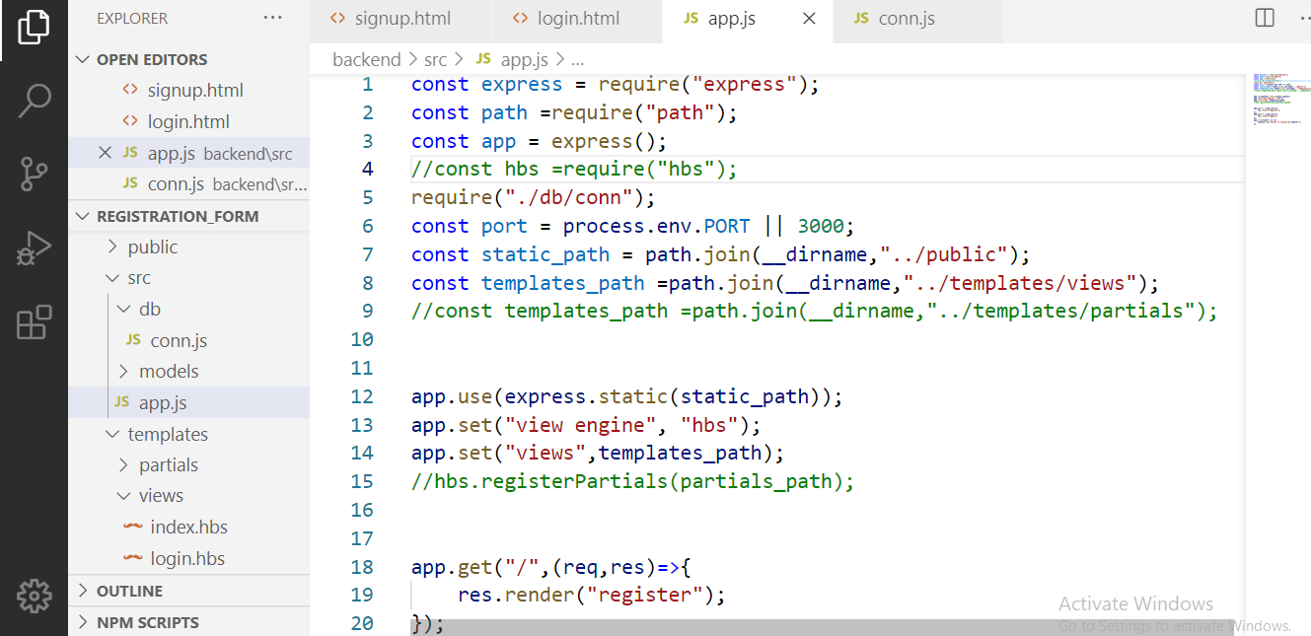

App.js file

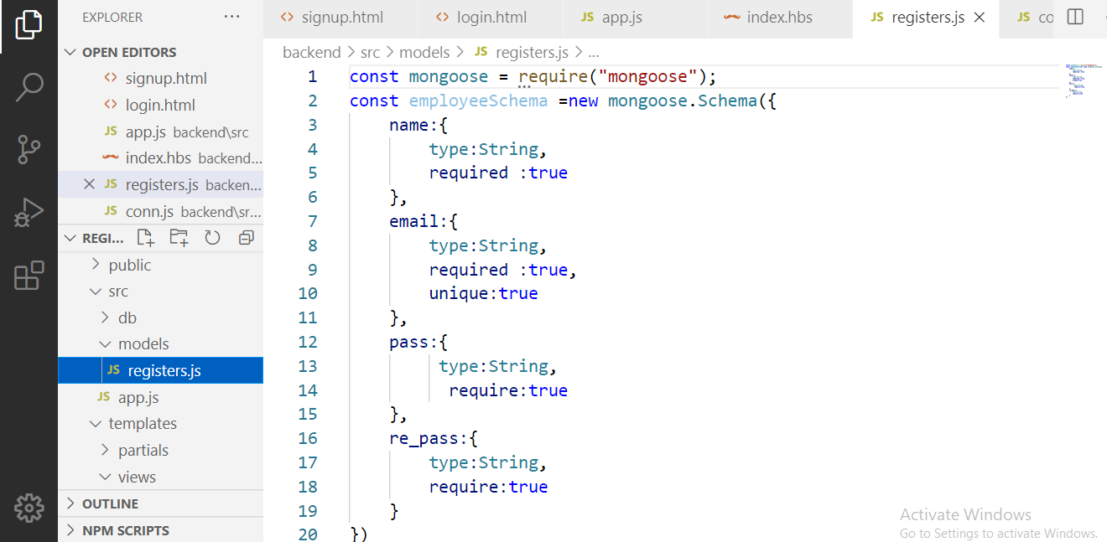

Mongoose Connection file

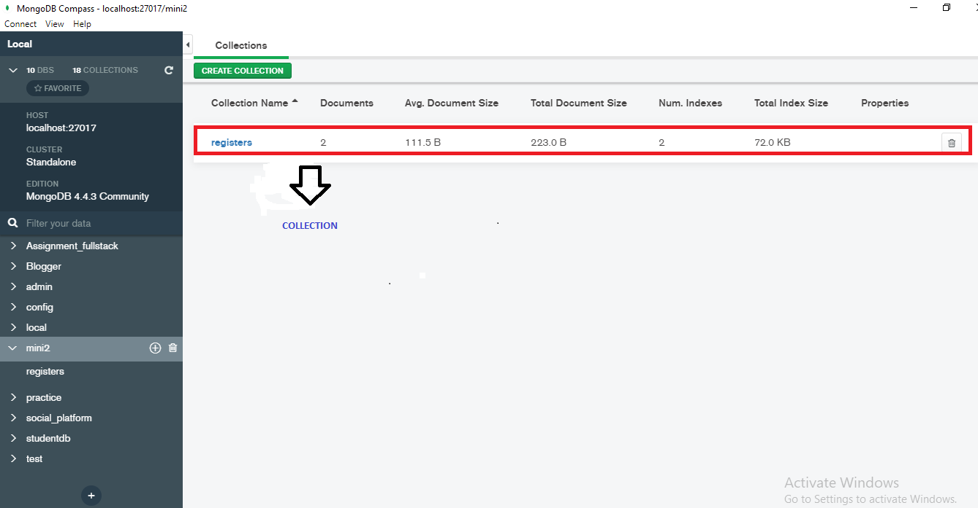

Collection Name in database (Mongodb)

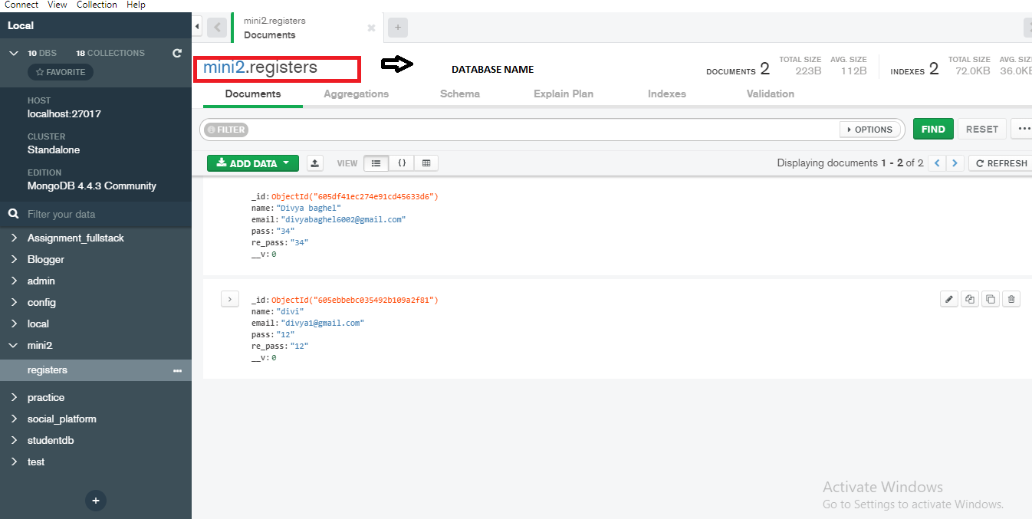

Database Connection in Mongodb.

**REFERENCES**

1. <https://www.w3schools.com/>
2. <https://www.beta-labs.in/>
3. https://stackoverflow.com/